
A 10

Sreenidhi Institute of Science & Technology
(An Autonomous Institution)
Code No:

MASTER OF COMPUTER APPLICATIONS, FEBRUARY, 2012 (Regular)
MATHEMATICAL FOUNDATIONS OF COMPUTER SCIENCE

Time: 3 Hours Max. Marks : 60

Note : No additional answer sheets will be provided.

Part-A (Objective Type)
Max.Marks:10

Answer all the QUESTIONS.

1. A one - to - one function is also known as
a) injective function b) surjective function
c) bijective function d) none

2. Let A = {1,2,3,4} and the relation R is R={(1,2), (1,3), (4,2)} then R is
a) Non antisymmetric b) Not reflexive
c) Transitive d) Symmetric

3. The value of 75P₂ is
a) 2775 b) 150 c) 5550 d) none

4. P→Q is equivalent in logical form to
a) ⎤ PVQ b) ⎤ P ΛQ c) ⎤ PΛ⎤ Q d) PVQ

5. The area of logic that deals with quantifiers is called
a) Mathematical logic b) Predicate logic c) proportional logic d) none

6. A binary operation on a set G is sometimes called________________.

7. If G is a finite graph then the number of verifies in G denoted by |V(G)| is called ________________.

8. If G is a simple connected graph and also a tree then the number of spanning trees of G is / are_____________.

9. A collection of syntactic rules is called a _______________.

10. Two finite state machines are said to be equivalent, if they have _____________.

Part – B (Subjective Type)
Max. Marks: 50
Answer any Five. All questions carry equal marks.

1. a) Let A = {1,2,3,4,6,12}. On A, define the relation R by aRb is and only if "a" divides 'b' . Prove that R is a partial order on A. Draw the Hasse diagram for this relation.

b) Show that the relation greater than or equal to ≥ is a partial ordering on the set of integers.

2. a) Find the total number of positive integers that can be formed from the digits 1,2,3,4 and 5. If no digit is repeated in any one integer.

b) How many way's are there to roll two distinguishable dice to yield a sum that is divisible by 2?

3. a) 'a' and 'b' are integers if and only if ab is a rational number. Obtain the truth value of the above statement.

b) Show the following equivalence.
P→(Q→P) ⇔ ⎤ P → (P→Q)

4. a) Symbolize the statement 'Every one in final year class has a cellular phone'.

b) Prove the following arguments are valid (or) invalid
i) P→Q ii) (⎤ P V ⎤ Q) → (RΛS)
P→R ⎤ R→T
P ⎤ T
------ --------------------------
∴ R ∴ P.
5. a) Identify different paths for the following Graph (g) in a tabular form

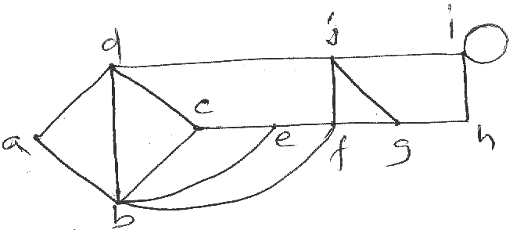
b) Draw the following graphs
i) C5 ii) K6

6. a) Find the fundamental circuits relative to the spanning tree as shown below
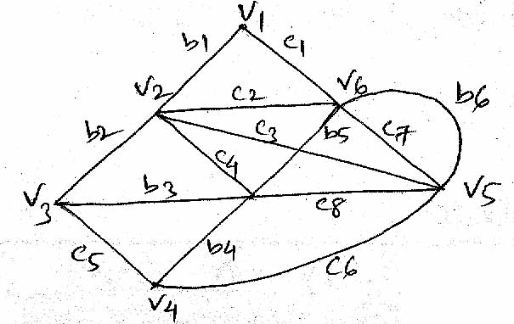
b) Examine the following graphs are planar or non - planar.
i) K₄ ii) K_{3,3}

7. a) Design FA which checks whether a given binary number is divisible by three.
b) Design a PDA to accept the language
L = { ω/ω ε (a+b)^{*-} and n_{a} (ω) = n_{b} (ω) }

-- 00 -- 00 --

